SETTING UP APPLICATION ENVIRONMENT

**FLASK CREATION**

|  |  |
| --- | --- |
| Team ID | PNT2022TMID18036 |
| Project Name | Smart Fashion Recommender Application |
| Team Members: | Ramyadevi RS  Samyuktha V  Srija J  Subiksha R |

Flask installation:

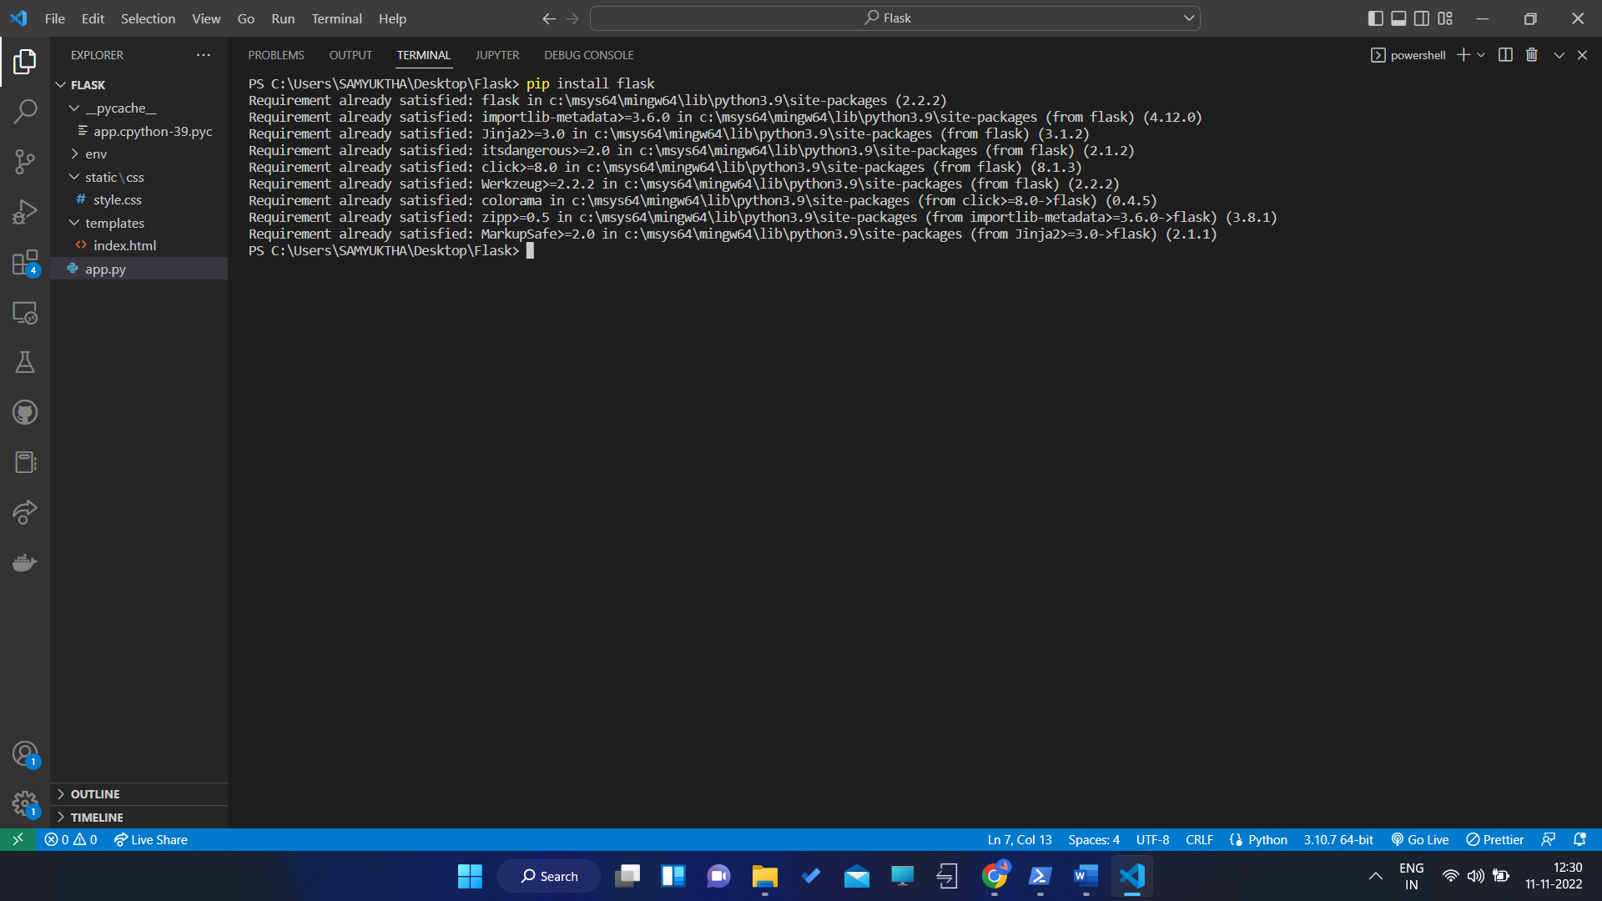

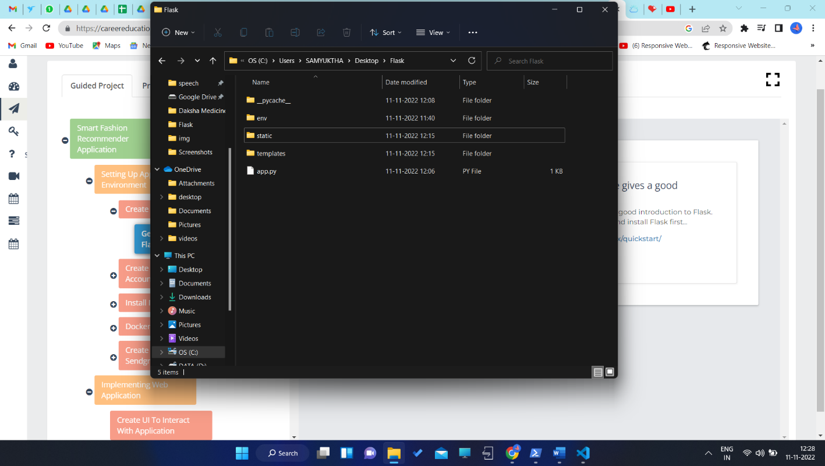

Create flask:

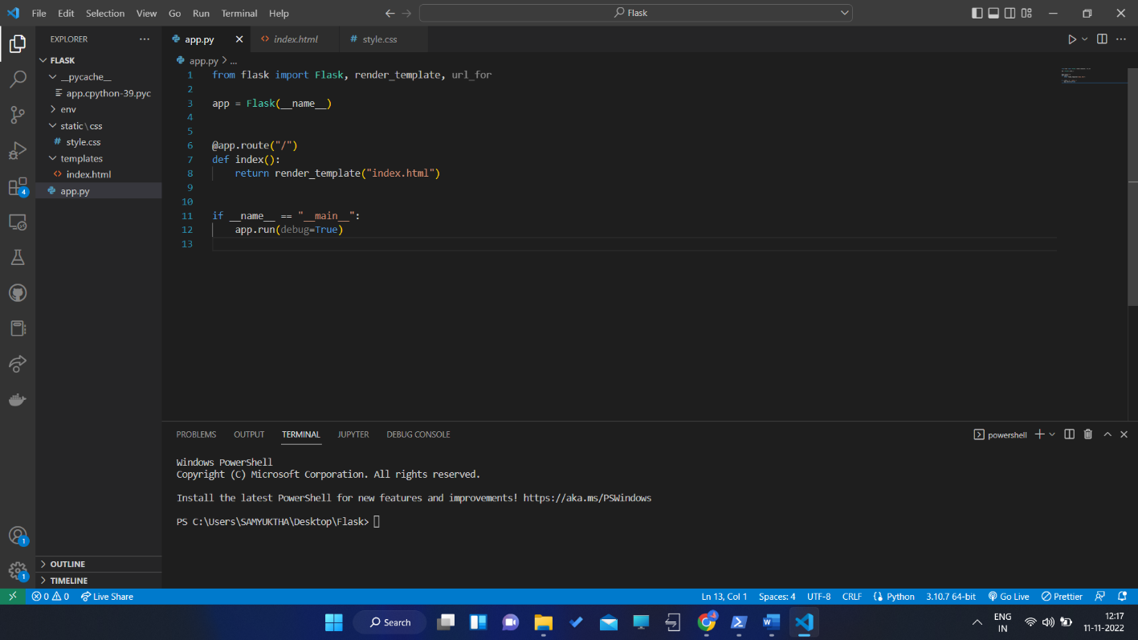

Run flask:

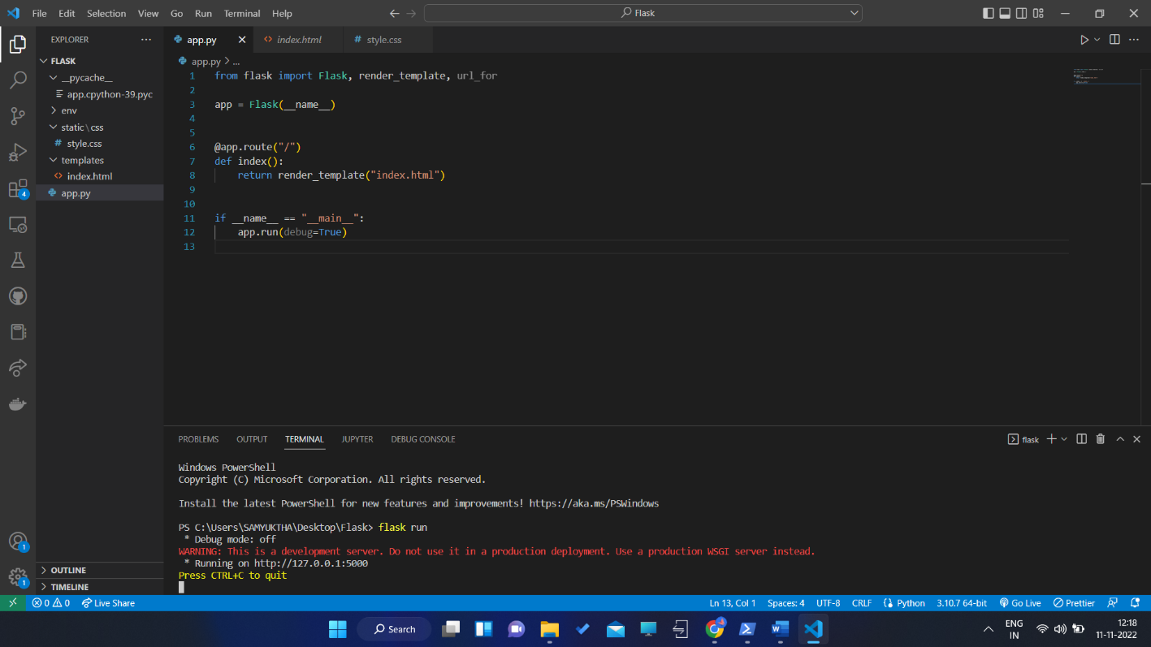

Output :

